1. Adding two numbers:

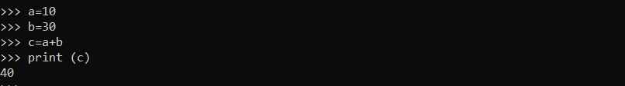

2.To print even index characters in the given string

